CTF

Swapnilshrestha.com.np

Step1:

Right click and go to view source code

There are many hash key in comment

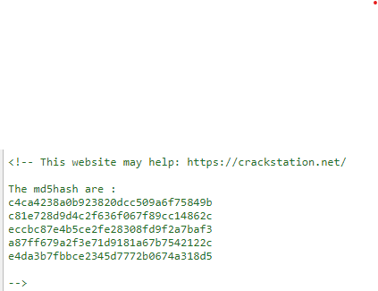

Crack hash key with crackstation website

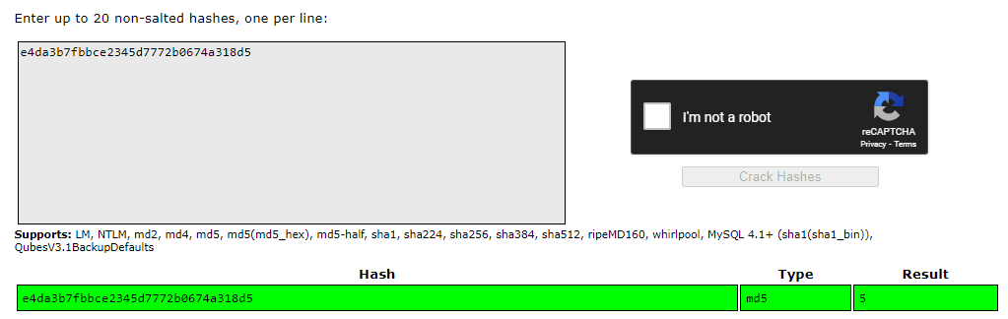

Now the for next directory enter all result one by one until get right result.

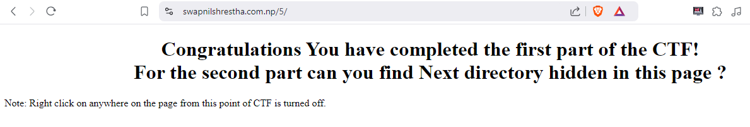

After find out next directory, because of right click is turn off on page then we use shortcut key for view source code (ctrl + u).

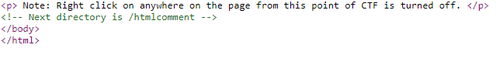

There is another hint for next directory. (/htmlcomment) now enter this on browser and get in next directory.

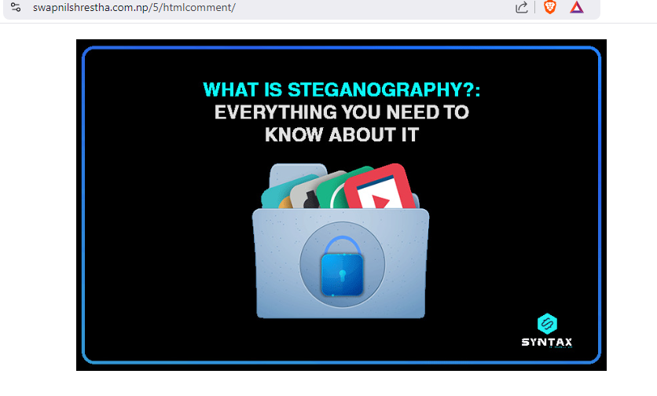

There is another encryption method steganography. And the image steganography is used to hide next directory hint (text).

Now we are going to decrypt this image with another tools steghide.

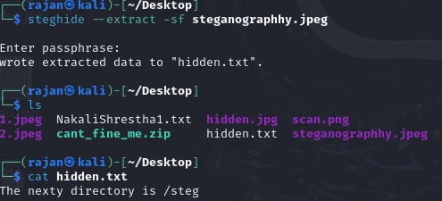

Here we get another hint for next directory (/steg).

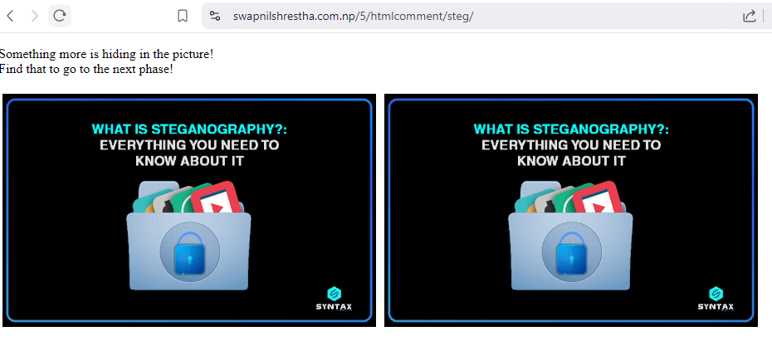

Here is another steganography to hide text for next directory. First we download both image from source code on desktop. Then again we used steghide command tools. If steghide command not work for this images, then we will try another command.

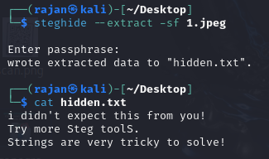

Here when we try steghide command for image1 there is information about use more steg tools for crack image 2.

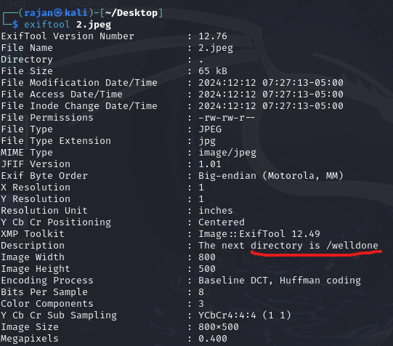

Here we used another steg tools (exiftool) and get another directory on description.

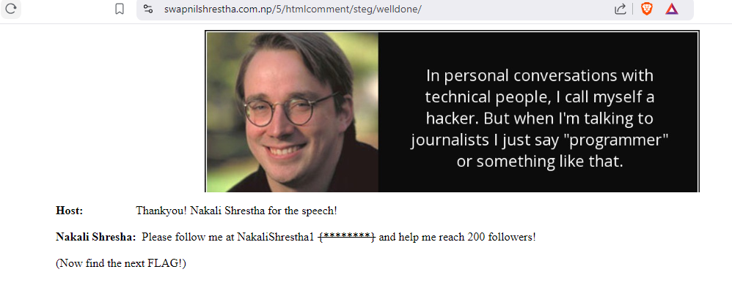

We get another CTF and hint like follow Nakkalishrestha1. This means we are going to use another tools Sherlock which help us to find out this user name on different social media.

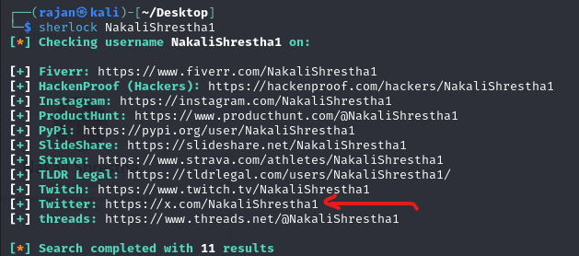

Here we search twitter link of Nakali Shrestha then we get another encoded key for next hint or directory

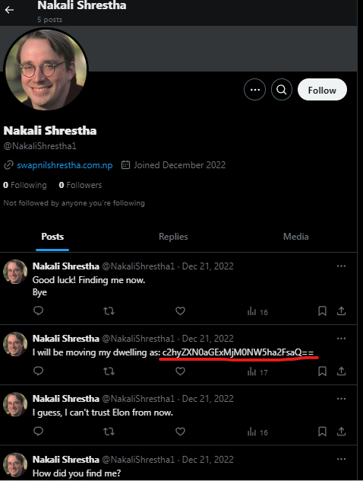

Now we use cyber chef tools to decode this key as this coded in Base64, a common encoding format.

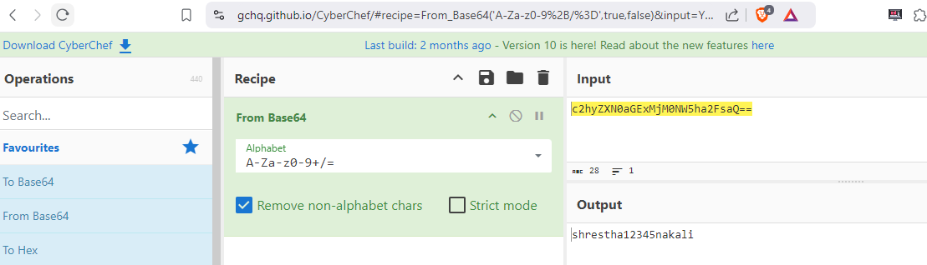

Here is another Username shrestha12345nakali is find out as a result. Now again we used Sherlock to find out related different social media by this username.

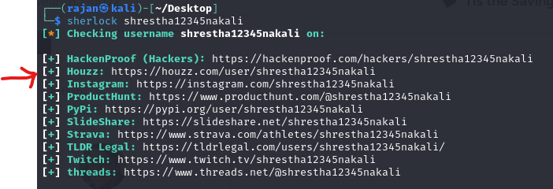

Again we try to open all link one by one until get another hints.

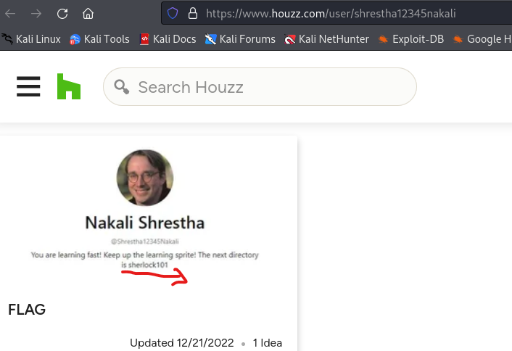

We get another directory (sherlock101) on website houzz.com

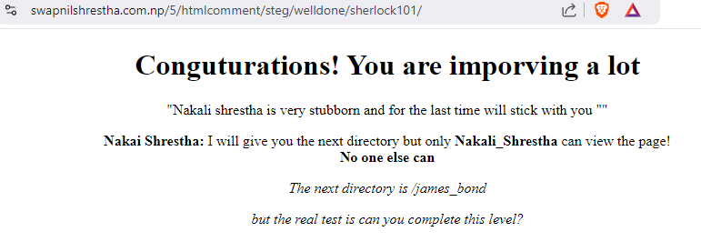

We get another page and another hints about next directory (james_bond) but this only work nakali_shrestha.

By pressing shortcut key ctrl + shift + I to inspect page. We are going to change user agent on network condition as nakali Shrestha only work next directory hints(james_bond)

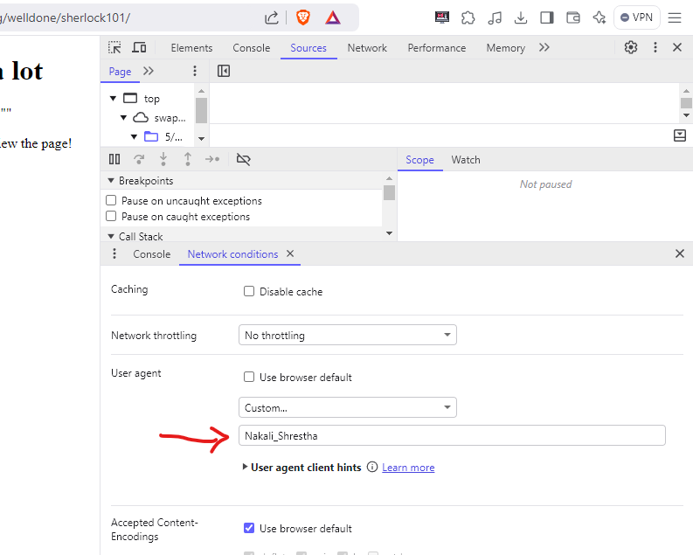

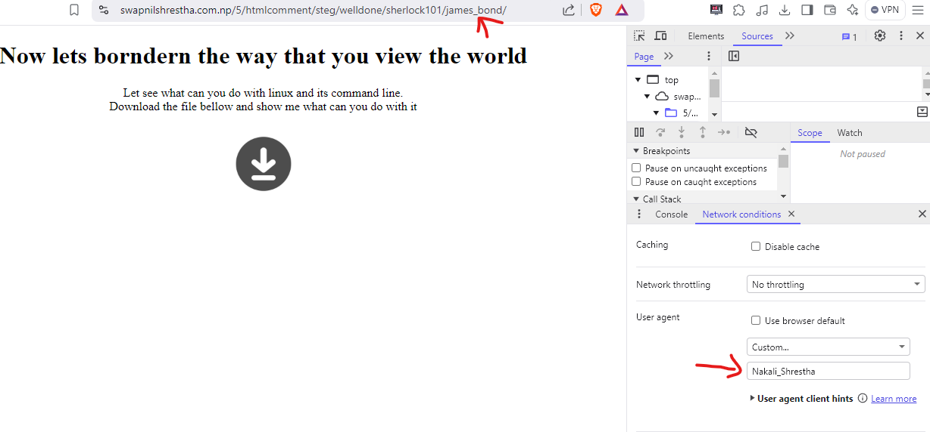

The next directory James_bond is work after change user agent. Download given file on page

After download that file unzip folder

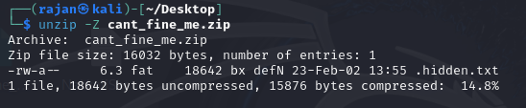

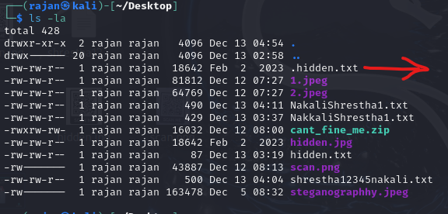

Now hidden.txt file translate into hidden.jpg file



After change into jpg format there is scan file create, after scanning that file another scan image is showed with google map link.

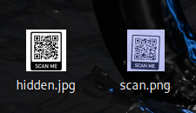

After scanning another scan file its show next directory (glocation) and get next stage of ctf.

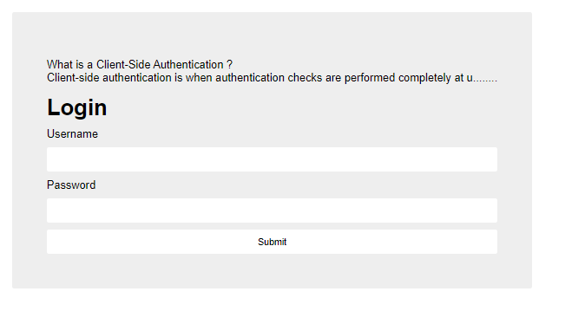

Client side authentication check by inspecting java script file of page.

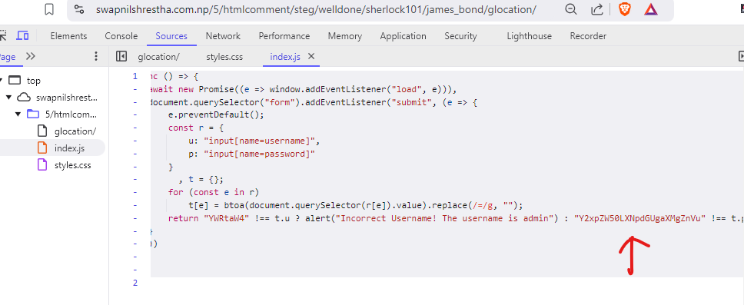

In java script here is encode key as a password. Then by help of cyber chef we decode the encrypt password.

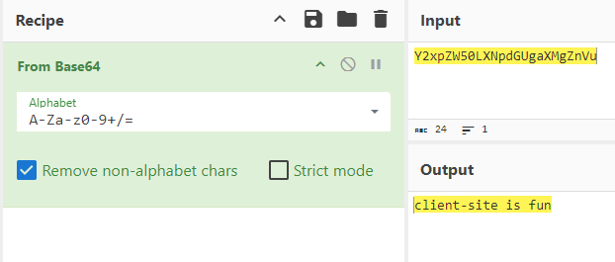

After get password we get next directory for next stage of CTF.

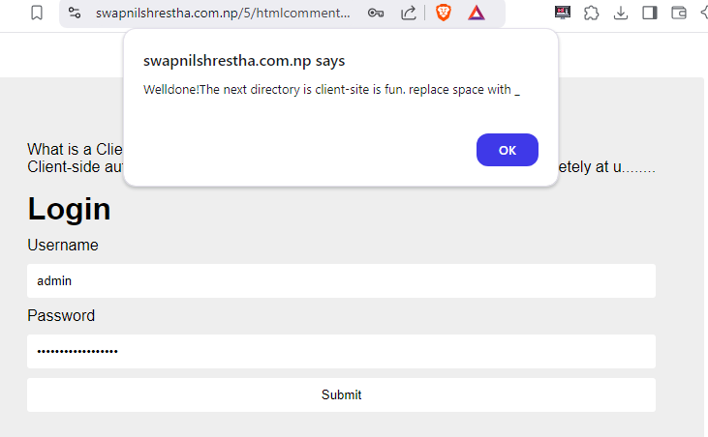

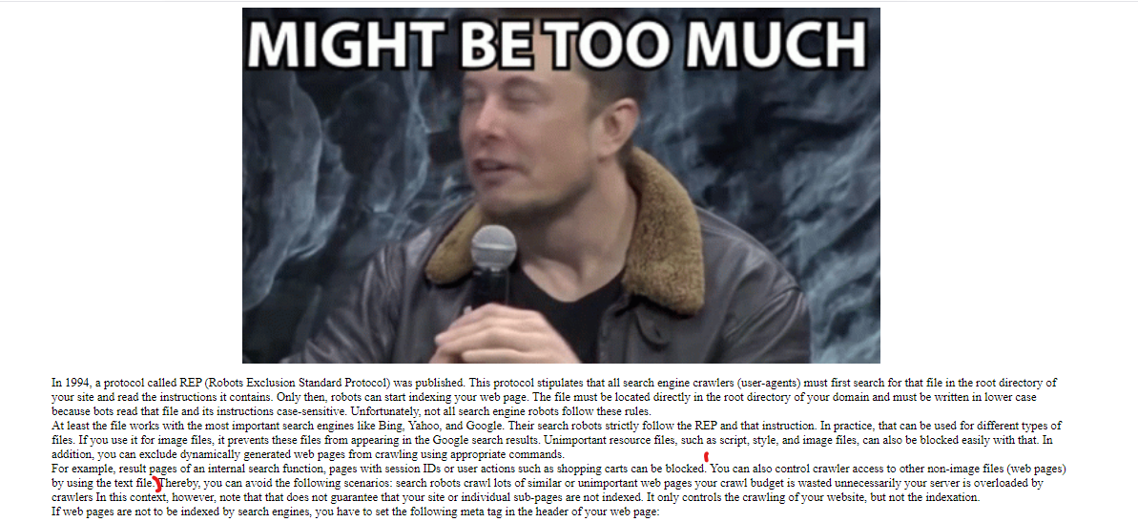

Used robots.txt on url for next directory. And we get first part of next directory and second part of next directory is in encrypted format.

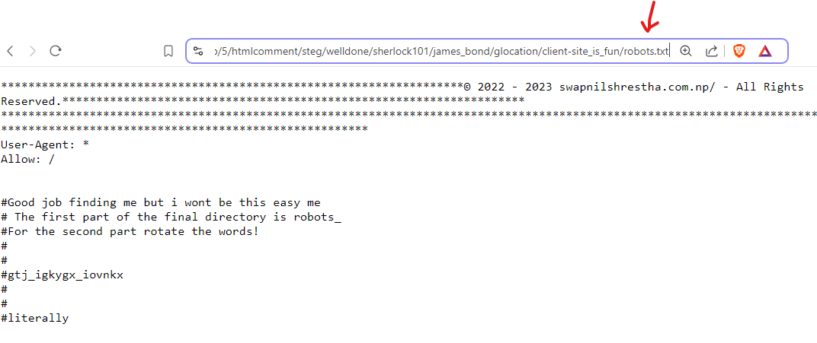

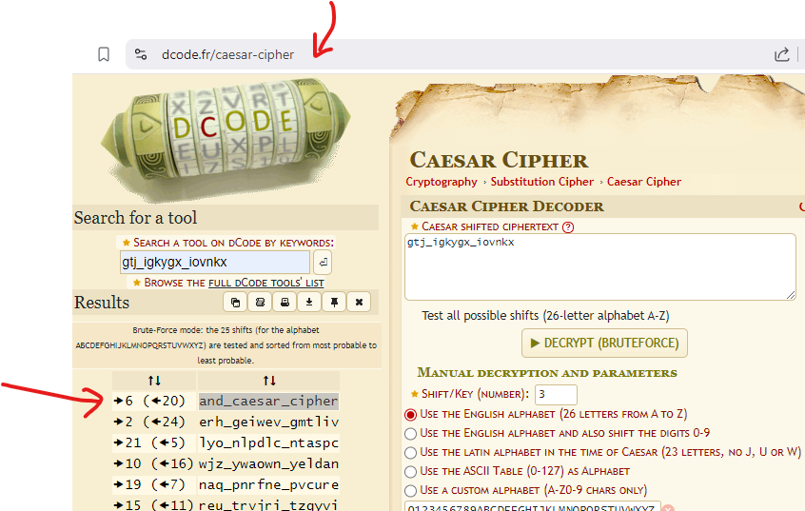

Here we used <https://www.dcode.fr/caesar-cipher> tools for decode encrypted key

Here we find another parts of next directory

